training 1 epoch...

835.9005331993103 seconds used......

1 training finished! average train loss: 0.2823409571682268

total clf loss: 289.67061549797654 total adv loss: 191.76772373216227

evaluating...

Confusion matrix, without normalization

[[ 43 68 23]

[ 32 1871 34]

[ 3 27 377]]

Normalized confusion matrix

[[0.32089552 0.50746269 0.17164179]

[0.01652039 0.96592669 0.01755292]

[0.00737101 0.06633907 0.92628993]]

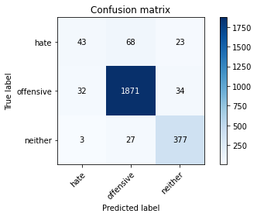

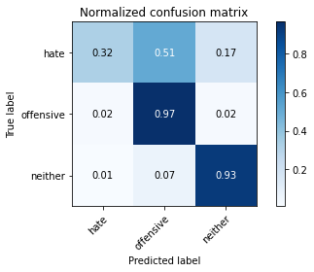

precision recall f1-score support

hate 0.55 0.32 0.41 134

offensive 0.95 0.97 0.96 1937

neither 0.87 0.93 0.90 407

accuracy 0.92 2478

macro avg 0.79 0.74 0.75 2478

weighted avg 0.92 0.92 0.92 2478

average eval_loss: 0.2302457575551084, accuracy: 0.9245359160613398

training 2 epoch...

834.808958530426 seconds used......

2 training finished! average train loss: 0.19980488102620228

total clf loss: 206.75291975401342 total adv loss: 170.9295591172995

evaluating...

Confusion matrix, without normalization

[[ 42 78 14]

[ 29 1887 21]

[ 5 46 356]]

Normalized confusion matrix

[[0.31343284 0.58208955 0.10447761]

[0.01497161 0.97418689 0.01084151]

[0.01228501 0.11302211 0.87469287]]

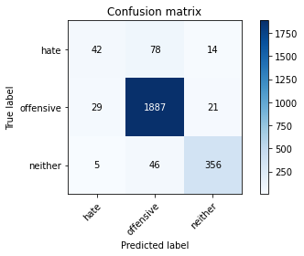

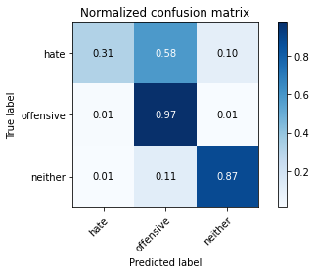

precision recall f1-score support

hate 0.55 0.31 0.40 134

offensive 0.94 0.97 0.96 1937

neither 0.91 0.87 0.89 407

accuracy 0.92 2478

macro avg 0.80 0.72 0.75 2478

weighted avg 0.91 0.92 0.92 2478

average eval_loss: 0.23434247746462783, accuracy: 0.9221146085552865

training 3 epoch...

835.0792405605316 seconds used......

3 training finished! average train loss: 0.139946478352114

total clf loss: 147.67424212954938 total adv loss: 176.946706736926

evaluating...

Confusion matrix, without normalization

[[ 45 72 17]

[ 36 1873 28]

[ 4 32 371]]

Normalized confusion matrix

[[0.3358209 0.53731343 0.12686567]

[0.01858544 0.96695922 0.01445534]

[0.00982801 0.07862408 0.91154791]]

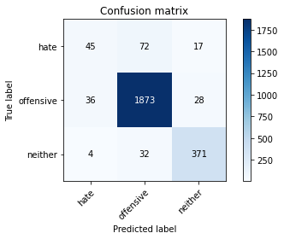

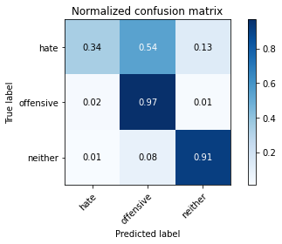

precision recall f1-score support

hate 0.53 0.34 0.41 134

offensive 0.95 0.97 0.96 1937

neither 0.89 0.91 0.90 407

accuracy 0.92 2478

macro avg 0.79 0.74 0.76 2478

weighted avg 0.92 0.92 0.92 2478

average eval_loss: 0.2535002458757991, accuracy: 0.923728813559322

training 4 epoch...

835.2882821559906 seconds used......

4 training finished! average train loss: 0.08107062443999777

total clf loss: 89.75100193894468 total adv loss: 186.5788475186564

evaluating...

Confusion matrix, without normalization

[[ 37 81 16]

[ 26 1882 29]

[ 4 37 366]]

Normalized confusion matrix

[[0.2761194 0.60447761 0.11940299]

[0.01342282 0.97160558 0.01497161]

[0.00982801 0.09090909 0.8992629 ]]

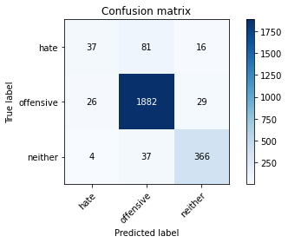

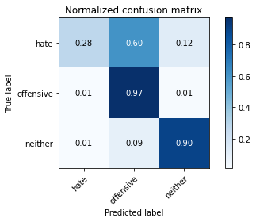

precision recall f1-score support

hate 0.55 0.28 0.37 134

offensive 0.94 0.97 0.96 1937

neither 0.89 0.90 0.89 407

accuracy 0.92 2478

macro avg 0.79 0.72 0.74 2478

weighted avg 0.91 0.92 0.91 2478

average eval_loss: 0.3194058322265083, accuracy: 0.9221146085552865

training 5 epoch...

835.3281772136688 seconds used......

5 training finished! average train loss: 0.03954381192905261

total clf loss: 48.96529387476039 total adv loss: 194.75664648320526

evaluating...

Confusion matrix, without normalization

[[ 49 72 13]

[ 42 1868 27]

[ 12 40 355]]

Normalized confusion matrix

[[0.36567164 0.53731343 0.09701493]

[0.02168301 0.9643779 0.01393908]

[0.02948403 0.0982801 0.87223587]]

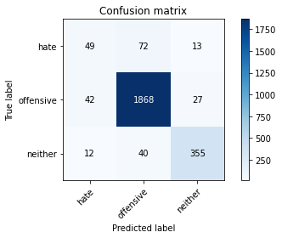

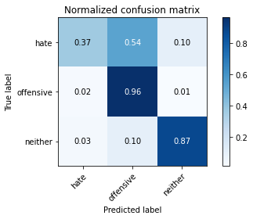

precision recall f1-score support

hate 0.48 0.37 0.41 134

offensive 0.94 0.96 0.95 1937

neither 0.90 0.87 0.89 407

accuracy 0.92 2478

macro avg 0.77 0.73 0.75 2478

weighted avg 0.91 0.92 0.91 2478

average eval_loss: 0.37898332633419834, accuracy: 0.9168684422921711

Confusion matrix, without normalization

[[ 49 70 5]

[ 75 1839 28]

[ 9 51 353]]

Normalized confusion matrix

[[0.39516129 0.56451613 0.04032258]

[0.03861998 0.94696189 0.01441813]

[0.02179177 0.12348668 0.85472155]]

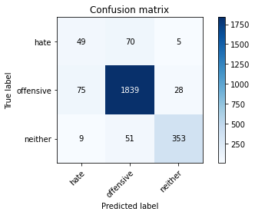

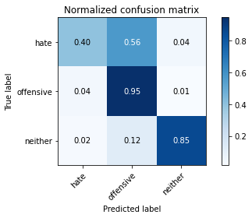

precision recall f1-score support

hate 0.37 0.40 0.38 124

offensive 0.94 0.95 0.94 1942

neither 0.91 0.85 0.88 413

accuracy 0.90 2479

macro avg 0.74 0.73 0.74 2479

weighted avg 0.91 0.90 0.90 2479

average eval_loss: 0.4130352672260825, accuracy: 0.9039935457845906

[17]:

0.9039935457845906